**Analysis of Grocery Shopping Trends**



Professor Cassó Domínguez

December 20, 2022

**Team:**

Avi Dhruva U13239444

Minsoo Kim U53551047

Ojas Arun U30300932

Abdul Rahman El Alayli U51159919

Nancy Lin U58841103

Julie Kang U05902743

BA222 A1

**1. Introduction**

The topic being discussed is grocery shopping - an easily overlooked, but necessary routine of everyone’s lives. Understanding what factors contribute to, if any, the success or failure of grocery stores was the primary objective when choosing this topic. Proper surveys and the analysis of their results may uncover correlations that may serve as financially useful information when operating a grocery store business. The data was collected by survey through Qualtrics through which questions regarding demographics and shopping behaviors were asked. Some business-related insights hoped to be gained include whether a correlation exists between income and expenditure on groceries, the importance of offering online grocery shopping, and what factors contribute to consumers selecting a particular store.

A few different methodologies were used in order to determine the relationship between various variables or just the significance of the variables themselves. First, various distribution methods such as histograms, bar charts, pie charts, and relative frequency tables were utilized in order to understand the distribution of the various variables. Second, the distribution of several important variables was observed across different demographic variables and some other categorical variables as well. Lastly, a few regression analysis was run in order to forecast two important variables and in order to observe the relationship between two other variables that seemed to be affected by omitted variable bias.

A surprise that went against the initial expectation was that upon analysis of the survey results, they indicated that average income didn’t affect average weekly expenditure. These results were surprising as it was expected that income would parallel spending, and maybe flatten out at higher incomes, however, that was not the case. Some other interesting observations were that those who have a preference for fresh produce yielded higher spending and that younger individuals advocated for more accessibility for online shopping. Although the analysis of the survey results indicate certain trends, it must be kept in mind that there exists a significant limitation regarding the data; that being an extremely limited sample size. Regardless, these results indicate preferences and trends that decision-makers can utilize to attract more customers, attract more customers by tailoring through online accessibility, and maximize customer spending.

**2. Data Description**

Initially, the observations totaled 215. The data was cleaned by removing incomplete and anonymous link responses while keeping responses received through QR codes and emails. After cleaning the data, clean responses totaled 156 observations.

For variables asking about spending habits, the unit of currency measurement is the U.S Dollar. For any variable measured in time, the value measured was in minutes. Question 7 asked whether the respondents believed that grocery shopping should be made more accessible on an online platform. For this question, the respondents answered on a scale of 1 to 5, so although the responses take a numerical form, it is treated as an ordinal categorical variable.

The survey consisted of 15 questions, but not all of them were of equal quality. Questions 5 and 8, which had to do with reasons for choosing the respondents’ preferred store, in particular, seemed to be flawed. According to the responses to question 8, price was the most important factor in determining where to shop, while convenience ranked among the least popular reasons. However, the responses to question 5 indicated that distance was the most important factor, which suggests that convenience is actually a crucial consideration. This contradiction suggests poorly written answer choices or the questions themselves were poorly worded, leading to low-quality results.

The survey sample may not be representative of the overall Boston population, as the majority of responses were collected on the Boston University campus. Based on the survey results, most of the respondents are between the ages of 21 and 24, and more than half earn an income of $0 to $50,000. The sample seems to better reflect the Boston University campus population, rather than aligning with the overall Boston population.

**2.1 Distribution Analysis**

The data analysis of the respondents using the medians, averages, and 1 standard deviation intervals revealed some common trends among the respondents. The majority of respondents were typically 21-23 years old, female (67%), students, and the primary decision-makers for household purchases. They also tended to have a household income under $25,000 (48%), multiple shoppers in their household, and spend $50 - 100 per week on purchases. These observations provide insight into the characteristics of the typical respondent in the survey.

The average age was 22.8 years, but this is skewed right due to a single outlier at 55 years old. Therefore, while the mean age is 22.8, the median age is actually 21. The minimum age of respondents was 21, and the maximum was 55 (see figure 5). Looking at the gender distribution, 67% of respondents identify as female, 30% as male, 2% as non-binaries, and the remainder prefer not to say (see figure 6). In terms of household income, 48% of respondents fall within the $0 - 25k income bracket, 17% in the $25 - 50k bracket, 9% in the $50 - 75k bracket, 7% in the $75 - 100k bracket, 5% in the $100 - 125k bracket, 1% in the $125 - 150k bracket, and 14% in the $150k and above income range. Clearly, a majority of the respondents earn between $0 and $50k (see figure 7).

One of the main variables of interest is the Weekly Expenditure of consumers. A distribution of the variable was made to observe its nature in response to other independent variables. At a glance, the majority of respondents’ weekly expenditure ranges from $20 - $100, with the average spending at $93 per week (see Figure 1).

**Figure 1: Distribution of weekly expenditure.**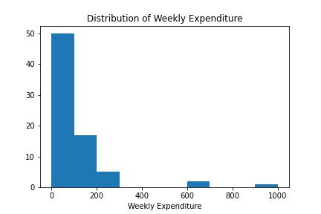

The frequency distribution for Online Accessibility Rating can be observed (see figure 8). Online accessibility for shopping was rated an average of 3.5 out of 5, with a standard deviation of 1.24. The minimum rating given was 1, while the maximum rating was 5. When looking at the percentile breakdown, it shows that 25% of respondents gave a rating of 2 or lower, while 50% of respondents gave a rating of 4 or lower. This means that the majority of respondents gave a rating of 4 or higher, indicating that the majority of people believe that grocery shopping should be made more accessible online**.**

Another important variable the team discussed was product categories which people tend to spend more on. The bar chart of the data shows that more people claim to spend more on fresh produce than any other product category. The others are quite close to one another, but Snacks is the second highest category with canned food at the bottom (see figure 9).

Looking at the bar chart of the average time people take to reach their preferred grocery store (see Figure 10), the majority of respondents take between 10-20 minutes. The second highest range of time is 5 - 10 minutes.

In order to see the top preferences consumers consider when selecting a grocery store, the team observed the number of people that believe in the importance of each factor. The results can be observed in the bar chart below (see Figure 2). It is clear that people prioritize distance, grocery selection, and price when selecting a grocery store, while considering other factors to be less important.

**Figure 2: Reason for Grocery Store Preference by percentages.**

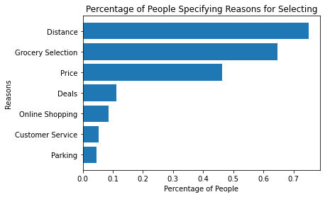

**2.2 Variable Relations**

It was observed that variations of characteristics in typical observations did exist based on income, product selection, age, and time taken to reach the preferred store. Hence, the team looked at various distributions of the main variables to observe connections to other demographic variables as well as other categorical variables.

1. **Weekly expenditure by income**

The variations of the average weekly expenditure by income group can be observed (see Table 1):

**Table 1: Average Weekly Expenditure by Income.**

| **Avg. Income** | **Weekly Expenditure ($)** |
| --- | --- |
| $0 - $25K | $67.17 |
| $25k - $50k | $141.54 |
| $50K - $75K | $123.33 |
| $75K - $100K | $146.66 |
| $100K - $125K | $96.66 |
| $125K- $150K | $80 |
| $150K < | $110.38 |

Initially a positive relationship between these two variables was expected. However, upon analysis, there seems to be little to no correlation, and seems almost random. Yet, this absence of relations is most likely due to the poor distribution of the average income demographic. Since a majority of the respondents (more than 60%) earned between $0 and $50K, it is difficult to conclude anything from this data.

1. **Weekly expenditure by product selection:**

The following graph shows the distribution of average weekly expenditure among the various product categories (see Figure 3).

**Figure 3: Average Weekly Expenditure by Product Category.**

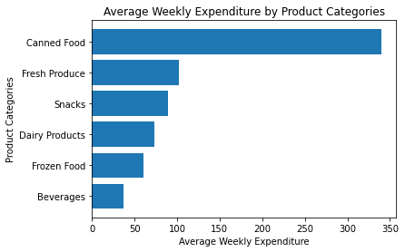

From these results, it is clear that those that selected Canned Food tend to spend more on average in a week. However, this is likely due to the fact that there are only 2 observations that selected Canned Food and one of them was a major outlier spending around $600 weekly on groceries. Otherwise, Fresh Produce and Snacks seem to have the highest weekly expenditures. These results match the results for the distribution of products people tend to spend more on. This relationship has been further discussed in the regression analysis section, seeing as this could be an interesting variable for policymaking for a grocery store.

1. **Online accessibility by age:**

A bar chart was generated to summarize the popularity of whether individuals grouped by age think that online shopping should be more accessible (see Figure 4). It appears that individuals under the age of 30, on average, feel that online shopping should be more accessible whereas individuals over the age of 30, on average, have less inclination toward online accessibility. These results can be explained by the fact that younger people generally have a better understanding of technology and have adapted to the advancements made in the past few years. Older individuals have already developed habits of physically shopping at stores and may not be as technologically adept compared to younger generations.

**Figure 4: Age Against Rating for Online Accessibility.**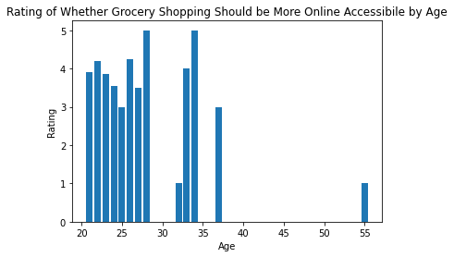

1. **Weekly expenditure by time:**

A table showing the average weekly expenditure by different time groups can be observed in the appendix (See Table 6). There seems to be no relation between the average weekly expenditure and the time taken to reach the grocery store. Once more, this is quite surprising considering the team expected somewhat of a decrease in average weekly expenditure, expecting people to tend to travel more in exchange for lower prices. However, this does not seem to be the case.

**3. Regression analysis  
 3.1 Forecasts:**

One business question the analysis aims to answer is *“What are the driving factors that impact a typical Boston resident’s weekly grocery spending?”* All grocery stores, large retailers or locally independent, should understand the various factors that customers consider when selecting where to shop for their groceries in order to maximize their profits. A regression model will help to predict the increase in weekly expenditure of consumers by using Weekly Expenditure as the dependent variable. The first variable included was the number of times people shop weekly as it had the highest correlation with weekly expenditure.

Another question that can be answered is “*Under what conditions can grocery stores use online accessibility to attract and retain customers?”* Forecasting the relationship between various factors and online accessibility can provide insight into which groups of consumers are most likely to value online accessibility. This information can help grocery stores tailor their online offerings and pricing strategies to better meet the needs and preferences of their target customers. Given the business-related question, using the rating for whether grocery stores should have more online accessibility as the dependent variable in the model is an obvious choice. The model is able to forecast the relationship between online accessibility and age, keeping other factors (such as income, employment status, etc.) that may influence a customer's willingness to want online accessibility controlled. This can provide valuable insights for grocery stores looking to optimize their online presence depending on the community they're in.

A correlation matrix of the variables is observed below (Table 2)

**Table 2: Correlation matrix between Weekly Expenditure and Online Accessibility.**

|  | **Weekly Expenditure** | **Online Accessibility** |
| --- | --- | --- |
| **Weekly Shopping** | 0.35 | -0.028 |
| **Age** | 0.054 | -0.22 |
| **Household Members** | 0.26 | 0.095 |
| **Money Spent On Eating Out [$120<]** | 0.37 | -0.12 |
| **Money Spent On Eating Out [$30 - $59]** | -0.18 | -0.13 |
| **Money Spent On Eating Out [$60 - $89]** | 0.065 | 0.11 |
| **Money Spent On Eating Out [$90 - $119]** | -0.044 | 0.12 |
| **Reason for Choosing a Store [Distance]** | 0.032 | -0.14 |
| **Reason for Choosing a Store**  **[Grocery Selection]** | 0.017 | -0.091 |
| **Shop For Multiple People [Yes]** | 0.163 | 0.14 |
| **Product Type [Canned Food]** | 0.25 | 0.013 |
| **Product Type [Dairy Products]** | -0.054 | 0.057 |
| **Product Type [Fresh Produce]** | 0.090 | -0.032 |
| **Product Type [Frozen Food]** | -0.088 | 0.10 |
| **Product Type [Snacks]** | -0.016 | -0.11 |
| **Type Of Employment [Full Time]** | -0.0014 | -0.10 |
| **Type Of Employment [Part Time]** | 0.0011 | 0.064 |
| **Type Of Employment [Student]** | 0.0070 | 0.044 |
| **Average Income [$100K - $125K]** | -0.026 | -0.0039 |
| **Average Income [$125K- $150K]** | -0.0048 | 0.013 |
| **Average Income [$25K - $50K]** | 0.036 | -0.13 |
| **Average Income [$50K - $75K]** | 0.047 | -0.13 |
| **Average Income [$75K - $100K]** | 0.083 | 0.056 |
| **Average Income [$150K<]** | 0.17 | 0.10 |

**a. Forecast for Weekly Expenditure:**

**Table 3: Regression Model Weekly Expenditure Forecast.**

|  | **Weekly Expenditure ($)** |
| --- | --- |
| **Intercept** | -143.41*** |
| **Money Spent On Eating Out [$120<]** | 134.011*** |
| **Money Spent On Eating Out [$30 - $59]** | 9.33 |
| **Money Spent On Eating Out [$60 - $89]** | 20.12 |
| **Money Spent On Eating Out [$90 - $119]** | 1.0067 |
| **Shop For Multiple People [Yes]** | 32.1012* |
| **Product Type [Canned Food]** | 279.16*** |
| **Product Type [Dairy Products]** | 71.59 |
| **Product Type [Fresh Produce]** | 98.35*** |
| **Product Type [Frozen Food]** | 77.70* |
| **Product Type [Snacks]** | 77.37* |
| **Number of Times Shopping Weekly** | 39.047*** |
| **Household Members** | 10.90 |
| **R-squared Adj.** | 0.30 |

The adjusted R-square value of 0.3022 implies that about 30.22% of the observations can be estimated using the model. The model was made in order to maximize the adjusted R-square value (see Table 3).

**b. Forecast for Online Accessibility:**

**Table 4: Regression Model Weekly Expenditure Forecast.**

|  | **Improve Online Accessibility** |
| --- | --- |
| **Intercept** | 5.47*** |
| **Age** | -0.10*** |
| **Average Income [$150 +]** | 0.62** |
| **Average Income [$125K- $150K]** | -0.05 |
| **Average Income [$100K - $125K]** | 0.08 |
| **Average Income [$75K - $100K]** | 0.32 |
| **Average Income [$50K - $75K]** | -0.54 |
| **Average Income [$25k - $50k]** | -0.37 |
| **Employment [Student]** | 2.10* |
| **Employment [Employed Part Time]** | 2.25** |
| **Employment [Employed Full Time]** | 2.47** |
| **Product Type [Snacks]** | -1.039** |
| **Product Type [Frozen Food]** | -0.13 |
| **Product Type [Fresh Produce]** | -0.69 |
| **Product Type [Dairy Products]** | -0.55 |
| **Product Type [Canned Food]** | -0.37 |
| **Reason for Choosing a Store [Grocery Selection]** | -0.38* |
| **Reason for Choosing a Store [Distance]** | -0.40* |
| **Spending on Eating Out [$90 - $119]** | -0.091 |
| **Spending on Eating Out [$60 - $89]** | 0.017 |
| **Spending on Eating Out [$30 - $59]** | -0.47* |
| **Spending on Eating Out [$120<]** | -0.96** |
| **R-squared Adj.** | 0.17 |

Based on the regression results, it appears that increasing online accessibility is beneficial to attract consumers of the younger age demographic. To be more specific, an increase of about 10 years in age results in an average rating of 1 point on the 1-5 scale for the question. This relationship is also statistically significant at a p-value of 0.001. An adjusted R-square value of 0.1665 implies that approximately 16.65% of the observations are consistent with the model.

**3.2 Policy - Making**

1. **Weekly Expenditure to Product Selection**

The final regression analysis was to answer the simple question - How does product selection affect a consumer’s expenditure at a grocery store? It is clear that grocery selection is a factor that consumers take into account when selecting their preferred grocery store from the pie chart (see figure 11). Hence, it would be interesting to find out whether there is a relationship between consumer expenditure and product selection, considering that grocery stores could use this information to gain a better understanding of what to keep in their inventory depending on the demographic they cater to.

Hence, in order to determine this relationship, a regression analysis with Weekly Expenditure as the dependent variable and Product Selection as the main independent variable was run. The resulting equation is as follows:

**Weekly Expenditure = 36.875 + 303.13 * (Canned Food) + 31.20 * (Dairy Products) + 64.55 * (Fresh Produce) + 18.89 * (Frozen Food) + 52.85 * (Snacks) + ERROR**

In order to correct for OVB, a correlation matrix showing all the correlations between Weekly Expenditure, the various product types and the other variables in the data was made. The entire correlation matrix can be seen in the appendix (see figure 9). From observing which variables show a correlation with both variables, the number of household members, shopping for multiple people, spending on eating out, and the number of times shopped weekly were added to the regression equation. Hence the estimated multivariate regression is as follows:

**Weekly Expenditure = -105.42 + 286.98 * (Canned Food) + 69.11 * (Dairy Products) + 99.04 * (Fresh Produce) + 75.92 * (Frozen Food) + 81.51 * (Snacks) + 12.25 * (Household Members) + 35.38 * (Shop for multiple People) + 130.15 * (Spending Eating Out [$120<] + 4.33 * (Spending on Eating Out [$30 - $59]) + 14.06 * (Spending on Eating Out [$60 - $89] + -3.38 * (Spending on Eating Out [$90 - $119]) + 29.42 * (Times Shopping Weekly)**

The variables for the main independent variables can be interpreted as follows:

**Intercept** - This is the average Weekly Expenditure for a consumer purchasing only Beverages

**Canned Food** - This is the average increase in Weekly Expenditure for someone purchasing Canned Food

**Dairy Products** - This is the average increase in Weekly Expenditure for someone purchasing Dairy Products

**Fresh Produce** - This is the average increase in Weekly Expenditure for someone purchasing Fresh Produce

**Frozen Food** - This is the average increase in Weekly Expenditure for someone purchasing Frozen Food

**Snacks** - This is the average increase in Weekly Expenditure for someone purchasing Snacks

**Table 5: Regression Model for Weekly Expenditure Against Product Type.**

|  | **Weekly Expenditure (Univariate)** | **Weekly Expenditure (Multivariate)** |
| --- | --- | --- |
| **Intercept** | 36.87 | -105.42** |
| **Product Type [Canned Food]** | 303.13*** | 286.98*** |
| **Product Type [Dairy Products]** | 31.20 | 69.11 |
| **Product Type [Fresh Produce]** | 64.55 | 99.037*** |
| **Product Type [Frozen Food]** | 18.89 | 75.92* |
| **Product Type [Snacks]** | 52.85 | 81.51* |
| **Household Members** |  | 12.25 |
| **Shop For Multiple People [Yes]** |  | 35.38* |
| **Spending on Eating Out [$120<]** |  | 130.15*** |
| **Spending on Eating Out [$30 - $59]** |  | 4.33 |
| **Spending on Eating Out [$60 - $89]** |  | 14.07 |
| **Spending on Eating Out [$90 - $119]** |  | -3.39 |
| **Number of Times Shopping Weekly** |  | 29.42*** |
| **R-squared Adj.** | 0.058 | 0.318 |

Observing the difference between the two regressions, it seems that the team was able to factor in for OVB as the beta coefficients are different. For instance, the intercept is 36.87 in the univariate model, which implies that people tend to spend more on average on beverages. However, upon factoring in other variables, the resulting intercept is -105.42 which makes more sense as people tend to spend more on other categories than beverages.

**4. Policy Discussion:**

Based on the regression analysis, it is clear that grocery stores should prioritize stocking a wide variety of fresh produce, snacks, and dairy products, as these are the items that tend to generate the most revenue, particularly in areas near universities. In addition, the findings suggest that it may be more effective for grocery stores to focus on encouraging customers to visit their store more frequently, rather than trying to lure them in for one-time, large purchases. This strategy is supported by the fact that the number of times a customer shops at a store each week was the most significant predictor of their overall spending.

The final suggestion for grocery stores located in localities with younger demographics is to invest vastly in online grocery shopping alternatives. There is a clear indication that younger people tend to want higher online accessibility for groceries, and trading off the convenience of shopping online may even be worth paying higher prices. Hence, the team highly recommends stores in such localities to invest in online shopping.

**5. Conclusion**

After seeking out and surveying individuals on grocery shopping behavior, two main takeaways emerged for what grocery stores may find helpful in maximizing consumer attraction and monetary gain: product selection and online accessibility.

The data collected allowed further understanding of factors that may cause an increase in weekly expenditures and lead to higher profits, however, the collected data was highly biased as revealed from the team’s distribution analysis, showing that most of the respondents were between the ages of 21-25 and in the income bracket of $ 0-$ 50K.

Likely due to these biases, an initial theory that higher income would yield higher spending at stores was rendered false as there was no relation between those two variables, as revealed from the statistical associations analysis. Furthermore, the association analysis also showed no relation observed between the time taken to reach grocery stores and the weekly expenditure, which was quite surprising. After accounting for bias with canned foods, the statistical association analysis also revealed that those who shop for fresh produce tend to spend more when compared to other products.

The regression analyses conducted revealed some interesting results. Models for forecasting both weekly expenditure and online accessibility were made, the latter of which shows a strong negative correlation between age and online accessibility, implying online grocery shopping is a large industry that can be explored in areas concentrated in younger demographics. The policy-making regression also revealed a high expenditure on fresh produce, leading to our suggestions to focus on maintaining a regular stock of fresh produce and snacks more than other products.

In conclusion, the survey revealed some interesting trends - some that were not initially expected and others that were foreseeable. It also undermined some initial expectations, however, an analysis of the results was able to reveal some trends in the grocery industry that could be potentially useful for grocery stores.

**6. Appendix**

**Figure 5: Distribution of recipient ages.**

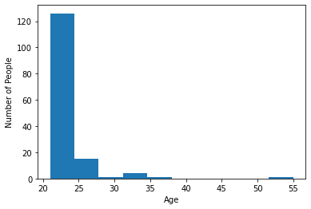

**Figure 6: Frequency distribution of Gender.**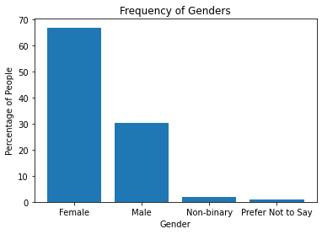

**Figure 7: Distribution of Recipients’ income brackets.**

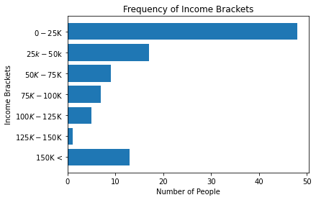

**Figure 8: Distribution of Wanting Grocery Shopping to be More Accessible Online.**

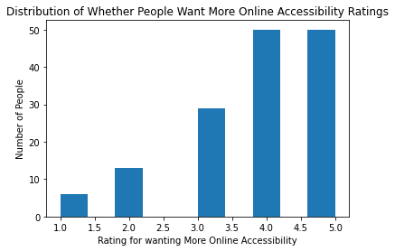

**Figure 9: Product preference among recipients.**

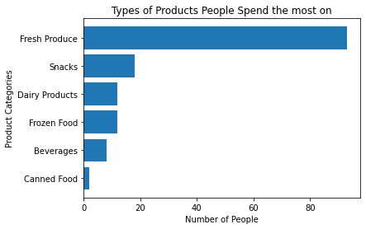

**Figure 10: Frequency of how long it takes respondents to reach the grocery store as a bar graph.**

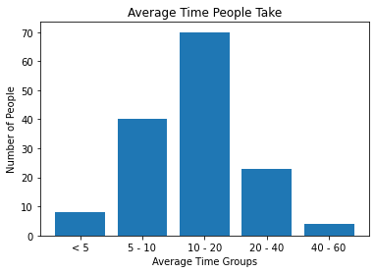

**Table 6: Average weekly expenditure grouped by time it takes to reach the grocery store.**

| **Time Taken** | **Weekly Expenditure ($)** |
| --- | --- |
| **< 5** | **$58.87** |
| **5 - 10** | **$98.17** |
| **10 - 20** | **$92.80** |
| **20 - 40** | **$90.86** |
| **40 -60** | **$187.50** |

**Figure 11: Observing whether grocery selection affects decisions.**

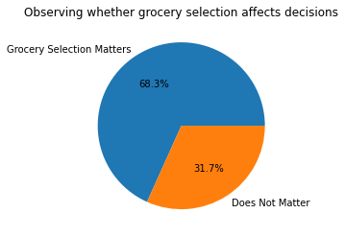

**Table 7: Correlation matrix for different variables, including food categories and weekly expenditures.**

|  | Weekly Expenditure | Category_Food_Canned Food | Category_Food_Dairy Products | Category_Food_Fresh Produce | Category_Food_Frozen Food | Category_Food_Snacks |
| --- | --- | --- | --- | --- | --- | --- |
| **Weekly Shopping** | 0.35 | 0.0053 | -0.046 | 0.00047 | -0.046 | 0.066 |
| **Is Online Accessible** | 0.094 | 0.00033 | 0.081 | -0.037 | -0.019 | -0.016 |
| **More Online Accessible** | 0.033 | 0.013 | 0.057 | -0.032 | 0.10 | -0.11 |
| **Age** | 0.054 | -0.053 | -0.076 | -0.010 | 0.15 | -0.010 |
| **Household Members** | 0.26 | 0.045 | -0.044 | 0.067 | -0.090 | -0.0081 |
| **Destination Time [20 - 40]** | -0.014 | -0.048 | 0.081 | 0.076 | -0.055 | -0.040 |
| **Destination Time [40 - 60]** | 0.13 | -0.019 | -0.048 | 0.0478 | -0.048 | -0.060 |
| **Destination Time [5 - 10]** | 0.018 | 0.19 | -0.0076 | -0.16 | 0.16 | 0.1060 |
| **Destination Time [< 5]** | -0.074 | -0.027 | -0.069 | 0.13 | -0.069 | 0.0053 |
| **Spending on Eating Out [$120<]** | 0.37 | 0.149 | -0.020 | -0.075 | -0.10 | 0.074 |
| **Spending on Eating Out [$30 - $59]** | -0.18 | -0.081 | -0.052 | 0.057 | 0.052 | -0.043 |
| **Spending on Eating Out [$60 - $89]** | 0.065 | 0.085 | 0.095 | 0.0052 | 0.034 | 0.018 |
| **Spending on Eating Out [$90 - $119]** | -0.044 | -0.043 | -0.036 | 0.099 | -0.036 | 0.047 |
| **Reason for Choosing a Store [Distance]** | 0.032 | 0.066 | 0.11 | -0.059 | 0.055 | 0.21 |
| **Reason for Choosing a Store**  **[Grocery Selection]** | 0.017 | -0.156 | 0.063 | 0.16 | 0.11 | -0.070 |
| **Reason for Choosing a Store**  **[Customer Service]** | 0.30 | -0.027 | -0.069 | 0.068 | -0.069 | 0.0054 |
| **Reason for Choosing a Store**  **[Price]** | -0.028 | -0.10 | 0.021 | 0.049 | 0.070 | 0.026 |
| **Reason for Choosing a Store**  **[Parking]** | 0.11 | -0.025 | -0.064 | -0.016 | 0.17 | 0.017 |
| **Reason for Choosing a Store**  **[Shopping]** | 0.062 | -0.035 | 0.085 | -0.043 | -0.090 | 0.11 |
| **Reason for Choosing a Store**  **[Deals]** | 0.033 | -0.041 | -0.026 | 0.11 | -0.026 | -1.79E-18 |
| **Shop For Multiple People**  **[Yes]** | 0.16 | -0.033 | 0.067 | 0.20 | 0.016 | -0.11 |
| **Employment**  **[Employed Full Time]** | -0.0014 | -0.034 | -0.085 | -0.064 | 0.096 | 0.20 |
| **Employment**  **[Employed Part Time]** | 0.0011 | 0.13 | -0.11 | 0.11 | -0.041 | -0.141 |
| **Employment**  **[Student]** | 0.0070 | -0.060 | 0.18 | 0.12 | 0.012 | 0.038 |
| **Buying Role**  **[I split the decision-making responsibilities]** | 0.092 | -0.072 | 0.20 | 0.026 | -0.020 | -0.0027 |
| **Buying Role**  **[Provide input, but am not the decision maker]** | -0.043 | -0.016 | 0.13 | -0.080 | -0.041 | 0.095 |
| **Gender [Male]** | -0.082 | 0.056 | -0.020 | 0.055 | 0.034 | -0.093 |
| **Gender [Non-binary]** | 0.090 | -0.016 | -0.041 | -0.080 | -0.041 | 0.095 |
| **Gender [Prefer not to say]** | -0.032 | -0.0093 | -0.024 | -0.100 | -0.024 | 0.22 |
| **Average Income [$100K - $125K]** | -0.026 | -0.025 | -0.064 | 0.048 | 0.17 | -0.080 |
| **Average Income [$125K- $150K]** | -0.0048 | -0.013 | -0.034 | 0.092 | -0.034 | -0.042 |
| **Average Income [$25k - $50k]** | 0.036 | -0.051 | -0.063 | 0.10 | 0.0026 | 0.0032 |
| **Average Income [$50K - $75K]** | 0.047 | 0.18 | 0.0053 | 0.035 | -0.085 | 0.044 |
| **Average Income [$75K - $100K]** | 0.083 | -0.029 | 0.030 | -0.083 | 0.030 | 0.17 |
| **Average Income [150K<]** | 0.17 | -0.045 | -0.041 | 0.073 | 0.031 | 0.039 |